**Lab: DOM Events**

Problems for in-class lab for the ["JavaScript Advanced” course @ SoftUni](https://softuni.bg/courses/js-advanced)". Submit your solutions in the SoftUni judge system at <https://judge.softuni.bg/Contests/2762/DOM-Manipulation-and-Events-Lab>

**Environment Specifics**

Please, be aware that every JS environment may **behave differently** when executing code. Certain things that work in the browser are not supported in **Node.js**, which is the environment used by **Judge**.

The following actions are **NOT** supported:

* **.forEach()** with **NodeList** (returned by **querySelector()** and **querySelectorAll()**)
* **.forEach()** with **HTMLCollection** (returned by **getElementsByClassName()** and **element.children**)
* Using the **spread-operator** (**...**) to convert a **NodeList** into an array

If you want to perform these operations, you may use **Array.from()** to first convert the collection into an array.

## List of Items

Write a function that **read** the text inside an input field and **appends** the specified text to a list inside an HTML page.

### Examples

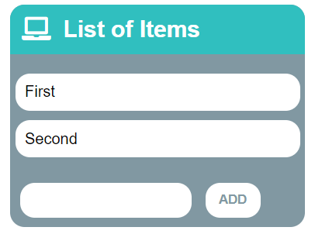🡪 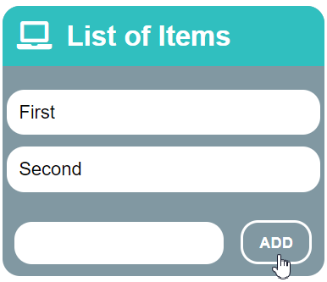🡪 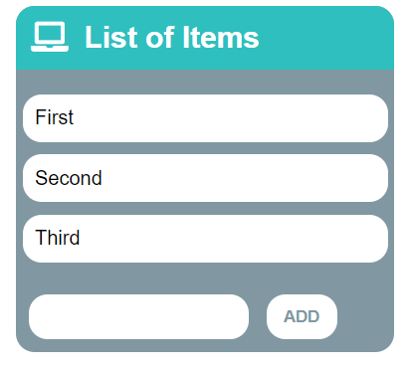

## Add / Delete

Extend the previous problem to display a **[Delete] link** after each list item. **Clicking** it, should **delete** the item with no confirmation. You have to add **href="#"** to the link element.

### Examples

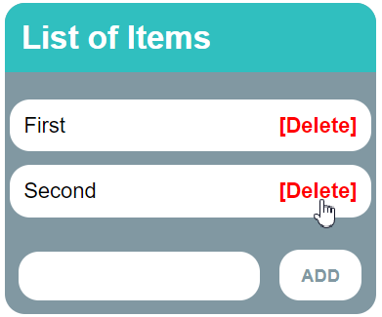🡪 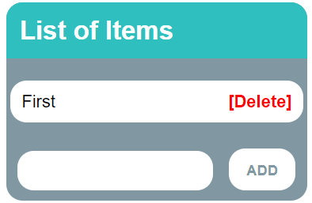

## Delete from Table

Write a program that **takes** an **e-mail** from an **input field** and **deletes** the matching row from a table. The textContent in the element with id="result" must be set to "Deleted". If no entry is found, an **error** should be displayed in a **<div>** with ID "**results**". The error should be "**Not found**." Submit **only** the **deleteByEmail()** function in judge.

**Input/Output**

There will be no input/output, your program should instead **modify** the DOM of the given HTML document.

**Examples**

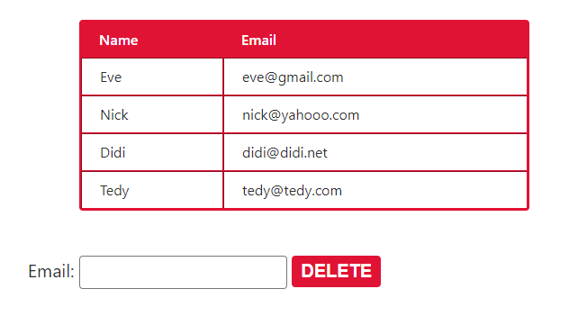

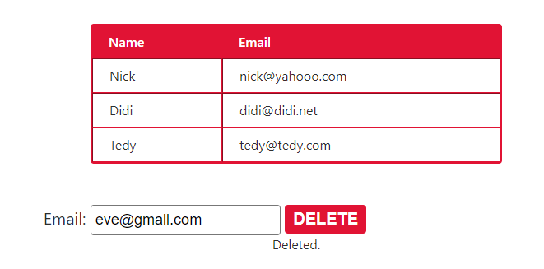

## Mouse Gradient

Write a program that **detects** and **displays** how far along a gradient the user has **moved** their **mouse**. The result should be **rounded down** and displayed as a **percentage** inside the **<div>** with ID "**result**".

Submit **only** the **attachGradientEvents()** function in judge.

**Input/Output**

There will be no input/output, your program should instead **modify** the DOM of the given HTML document.

**Examples**

Screenshot_2.png

## Highlight Active

Write a **function** that **highlights** the **currently active** section of a document. There will be **multiple** divs with **input fields** inside them. Set the **class** of the **div** that contains the **currently focused** input field to "**focused**". When focus is lost (**blurred**), **remove the class** from the element.

Submit only the **focused()** function in judge.

**Input/Output**

There will be no input/output, your program should instead **modify** the DOM of the given HTML document.

**Example**

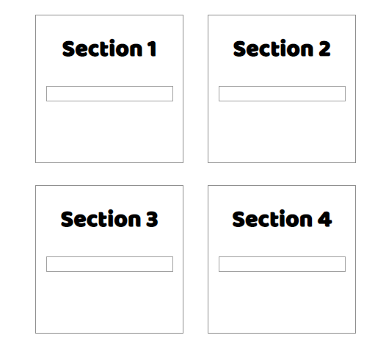 🡪 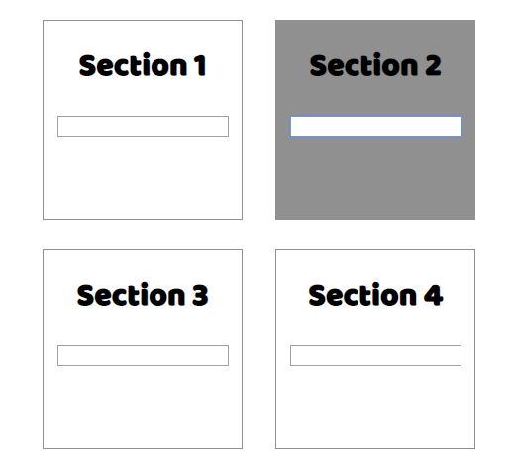

## Dynamic Validation

Write a **function** that **dynamically validates** an **email** input field when it is **changed**. If the input is **invalid**, apply the style "**error**". Do **not** validate on every keystroke, as it is annoying for the user, consider only **change** events.

A valid email is considered to be in the format: **<name>@<domain>.<extension>**

Only **lowercase Latin characters** are allowed for any of the parts of the email. If the input is valid, **clear** the style. Submit **only** the **validate()** function in judge.

**Input/Output**

There will be no input/output, your program should instead **modify** the DOM of the given HTML document.

**Example**

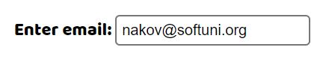🡪 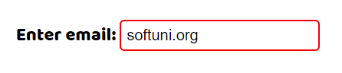

## Shopping Cart

You will be given some products that you should be able to add to your cart. Each product will have a name**,** pictureand aprice.

When the **"Add"** button is clicked, append the current product to the textarea in the following format: **"Added {name} for {money} to the cart.\n"**. The price must be fixed to the second digit.

When the button **"Checkout"** is clicked, calculate the **total money** that you need to pay for the products that are currently in your cart. Append the result to the textarea in the following format:

**"You bought {list} for {totalPrice}."**

The list should contain only the **unique products**, separated by **", "**. The total price should be rounded to the second decimal point.

Also, after clicking over "**Checkout**" and every from above is done you should **disable** **all** **buttons**. (You **can't** add products or checkout again, if once checkout button is clicked)

### Examples

